Data Privacy Impact Assessment (DPIA)

Submitting controller details
Name of controller | The Scott Practice
Subject/title of DPIA | Call Connect GP (formerly known as Patient Connect)
Name of controller contact /DPO  (delete as appropriate) | The Scott Practice  The Practice Data Protection Officer is Caroline Million, Independent Data Protection Officer. Any queries regarding Data Protection issues should be addressed to him at: -  Email: Caroline.million@outlook.com  Telephone 07912 975522

Step 1: Identify the need for a DPIA
Explain broadly what project aims to achieve and what type of processing it involves. You may find it helpful to refer or link to other documents, such as a project proposal. Summarise why you identified the need for a DPIA.
Deployment of CallConnect GP (CCGP) provides integration between our Primary Patient Clinical System (Emis) and the Redcentric Unity Cloud Hosted Telephony solution. (see attached documentation that provides a complete overview)
The DPIA is required as base (non-sensitive) demographic information is used from the Clinical System to match to inbound calls - CCGP is an approved EMIS Third Party Partner Solution with the primary features being (see benefits listed separately
- Time saving by intelligent matching of telephone numbers to Patient Demographics when answering calls – individual numbers, other patients who live at same address, shared numbers, linked numbers (son/daughter/carer), non patients
- Ability to preview EMIS Warnings and see other Priority Clinical Alerts/Tasks
- Notification of calls from “new” patients’ numbers with semi-automated accurate capture to the clinical record with audit trail
- Click to Dial from EMIS or anywhere on screen
- Practice Wide non-patient Address Book
- Taskbuster -Outbound contact tool linked to inbound responses
- Supports answering calls across Multiple Simultaneous Clinical System logins (Call Centre or Hub)
- Supports signposting a patient to eligible/more appropriate services
- Clear support for CQC - Highlighting Vulnerable Patients for an enhanced service and also trying to improve Clinical; Outcomes
Note all integration and interaction with the clinical System occurs locally on the users PC at the GP practice – the ONLY data interchange with the Hosted Unity Telephone platform is the passing of the inbound caller CLI (if not withheld) and the dial request to a telephone number for outbound calls

Step 2: Describe the processing
Describe the nature of the processing: how will you collect, use, store and delete data? What is the source of the data? Will you be sharing data with anyone? You might find it useful to refer to a flow diagram or other way of describing data flows. What types of processing identified as likely high risk are involved?
See attached documentation and information below
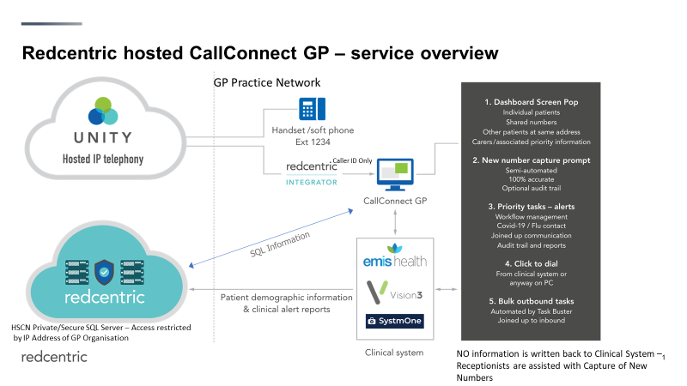
In the case of The Scott Practice Utilising the EMIS API, A demographic extraction tool is installed on nominated users PC (system manager) - the information used to power the solution is a subset of existing clinical system information and comprises
The extraction tool (which runs as a nightly scheduled task) looks for any changes to demographics and produces an XML report - this is then processed to extract/update information and destroyed.
Patient Demographics are kept in a Redcentric provided Secure HSCN Hosted SQL Server (best practice as per NHS-X) – Data Sharing agreements form part of the Redcentric Contracts
NOTE - no information is written back to the clinical system - Assisted Accurate New Number Capture is facilitated by the call handler and requires both housekeeping of existing numbers and the callers express consent to add the number to their demographics/clinical record or as a temporary number for a call
Data will be hosted on a Redcentric provided hosted SQL server - but Redcentric engineers will have no access to this data - Metier as providers of the CCGP software will “process” the data initially when setting up the system (chaperoned remote access via redcentric) but after this would only view data during training or when completing maintenance (metier offer to sign any confidentiality documentation as required by the Practice)

Describe the scope of the processing: what is the nature of the data, and does it include special category or criminal offence data? How much data will you be collecting and using? How often? How long will you keep it? How many individuals are affected? What geographical area does it cover?
The demographics used is a subset of basic clinical system data and comprises the following Patient Identifiable information
EMIS ID, Name, Address, DOB, Sex, Registered GP Practice/Usual Doctor, NHS Number , Telephone Numbers, Email Address
Additionally the Practice can supplement to Demographics with additional information based on Clinical System Reports - these are referred to as Highlighted Alerts (information such as Housebound or Action such as Flu)
The use of extracted demographics is key to the enhanced functionality provided by the CCGP solution – other more basic integrations simply try to match/search for the callers telephone number in the Clinical System - this will only assist in approx. 50% of calls …… When CCGP receives the telephone number for an inbound call it is not “just a number” but rather
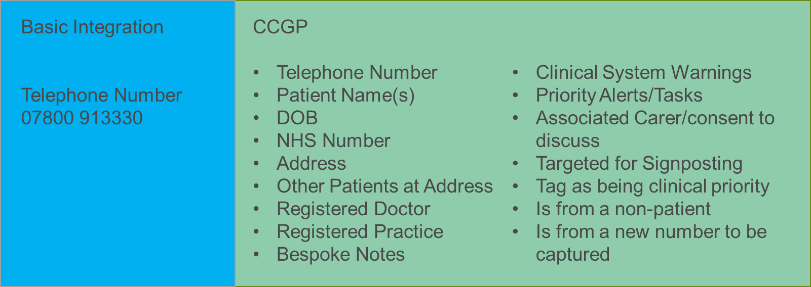

Data will be deleted should the Practice no longer wish to renew maintenance of the CCGP service after their initial period. (please not the CCGP middleware is able to link to other telephony platforms)

Describe the context of the processing: what is the nature of your relationship with the individuals? How much control will they have? Would they expect you to use their data in this way? Do they include children or other vulnerable groups? Are there prior concerns over this type of processing or security flaws? Is it novel in any way? What is the current state of technology in this area? Are there any current issues of public concern that you should factor in? Are you signed up to any approved code of conduct or certification scheme (once any have been approved)?
There are no real concerns as the CCG solution is just an enhancement to the established way the surgery provides a telephony service to patients currently
e.g. Phones rings, Receptionists Answers call, asks patient for 2 or more pieces of information to search within clinical system, starts a manual search, selects patients, see Emis Warnings and QoF/Other popups, deals with call.
However with CCGP
Phone Rings, Receptionist Answers, automatically a CCGP screen pop occurs matching caller ID to Demographics and displaying Warnings and Highlighted Priority Alerts, Receptionists confirms an additional piece of information to determine patient the call is about - clicks on the clinical system search button which displays patient (or in the case of S1 goes to home screen)
Any prompts to utilise a new number to “paste” into the clinical system are user controlled and requires patients permission/consent
Note anything such as Emis Warnings on the CCGP Dashboard are only displayed if the user is already logged into EMIS and can be password protected
The ethos of the CCGP solution is to enhance current ways of working, improving the service to patients and providing more information to the call handler and ensuring the best clinical outcomes are made from the telephone contact (avoiding Alert fatigue in Emis/S1)

Describe the purposes of the processing: what do you want to achieve? What is the intended effect on individuals? What are the benefits of the processing – for you, and more broadly?
The benefits of the solution are
Screen Pop & Clinical System selection - Speed up handling of all inbound calls (not just those simply matching to the caller) and improve patient access and staff efficiency/productivity
Overcome “Alert Fatigue” by seeing prompts about Priority Information or Tasks - allows the maximum benefit from the calls
Accurately capture New Telephone numbers, improve telephone triage success and effectiveness of any SMS solutions used
Click to dial - saves time avoids mis-dialling numbers and benefits from having numbers accurately captured by CCGP when booking appointments
Makes existing SMS solutions work better due to more up to date numbers - less SMS failures to process
Improves patient wait times, provides a better service

Step 3: Consultation process
Consider how to consult with relevant stakeholders: describe when and how you will seek individuals’ views – or justify why it’s not appropriate to do so. Who else do you need to involve within your organisation? Do you need to ask your processors to assist? Do you plan to consult information security experts, or any other experts?
Consent and use of data is covered by the fact the data is contained within the Primary Clinical System.
There are no new types of information/data being collected.
We recommend that in terms of advising Patients the following message is displayed in the Surgery/on their website
“We are implementing innovative technology that will recognise your telephone number when you call the surgery and allow our team to more quickly identify you and deal with your call. If you call from a new number that we do not have on record, we will ask you permission to use this number for future contact. If you wish to withhold your telephone number, please contact your telephone provider for instructions on how to achieve this,”

In additional the surgery can engage with their Patient Participation Group utilising the opportunity to promote the fact that

Step 4: Assess necessity and proportionality
Describe compliance and proportionality measures, in particular: what is your lawful basis for processing? Does the processing actually achieve your purpose? Is there another way to achieve the same outcome? How will you prevent function creep? How will you ensure data quality and data minimisation? What information will you give individuals? How will you help to support their rights? What measures do you take to ensure processors comply? How do you safeguard any international transfers?
The lawful basis is Medical related as the interaction with the patient is all via the Principal Clinical System – the CCGP Middleware’s only role to is to display information and facilitate selection of the patient - any clinical task are completed in the clinical system.
In terms of accuracy of data, minimising risks/errors and ensuring compliance, CCGP actually improves overall data quality at the practice by the accurate capturing of telephone numbers – in addition we highlight any anomalies such as
- Where the same telephone number is recorded against 2 patients at different addresses
- Where two patients at same address have had the address entered different (e.g apostrophes)
We can also profile
- 13-18 year old children who have a telephone number that is also in another adults record so the receptionist can be prompted to clarify numbers in use/consent for parents to linked
- Where a patient has no mobile number (with Action alert set to ask for a number when patient next calls)
- Where a patient has 2 or more mobile numbers in their record (it confuses SMS applications and may mean best number not being used)

All of the above reduces the risk of communications being made that compromises GDPR or patient confidentiality.
Any changes to demographics are updated in CCGP when updating from the clinical system, should a patient change numbers.
Lastly the Alerts can be used to compliance an example being a prompt to ask to record ethnicity or any other initiatives on data the Practice needs to undertake

Step 5: Identify and assess risks
Describe source of risk and nature of potential impact on individuals. Include associated compliance and corporate risks as necessary. | Likelihood of harm  Remote, possible or probable | Severity of harm  Minimal, significant or severe | Overall risk  Low, medium or high
CCGP service not being available – affecting all users  Redecentric HSCN Hosted SQl Server Compromised - potential access to Patient Demographic Information | Remote  Possible | Minimal  Minimal | Low  Low

Step 6: Identify measures to reduce risk
Identify additional measures you could take to reduce or eliminate risks identified as medium or high risk in step 5
Risk | Options to reduce or eliminate risk | Effect on risk |  | Residual risk |  |  | Measure approved
CCGP not Available  Redcentric HSCN Hosted SQl Server | The solution not being operational in no way limits the normal use of the telephone system or the ability to search for patients manually in the clinical system or dial phone numbers manually  By design the CCGP solution holds no information that is not inn the clinical system  Access is restricted to the originating HSCN IP of the Surgery  The SQL server instance is hardened and the server monitored and actively patched for security  Backups are made to quickly re-establish serve  The architecture has been independently PEN tested and is subject to all the assurances and extensive accreditations that Redcentric hold  Third party Access to the server (for Metier to maintain CCGP) is restricted and chaperoned by Redcentric IT Team | Negates risk  Mitigates Risk

Step 7: Sign off and record outcomes
DPO advice: Approve processing?
MILLION, Caroline (NHS SOUTH YORKSHIRE ICB - 03N)



To:
- FELLS, Rose (THE SCOTT PRACTICE)
Mon 8/22/2022 09:33
Hi Rose

This seems fine to me. Sounds like a useful system.

Regards
Caroline

Caroline Million

Independent DPO and IG Specialist
Caroline.million@outlook.com
07912 975522

DPO Signature:

DPO advice accepted or overruled, if overruled provide reasons:
Reasons:
This processing and this DPIA will be kept under review, next review date:

