

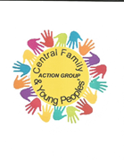

Central Children’s Library

Waterdale

DN1 3JE

Balby Library

High Road

Balby

DN4 0PL

Quaker Meeting House

Oxford Place

DN1 3SL

Alder Grove Church Hall

Alder Grove

DN4 8RF

Cantley Health Centre

10 Middleham Road DN4 6BZ

St Jude’s Church Hall

146 Shadyside Hexthorpe DN4 0DG

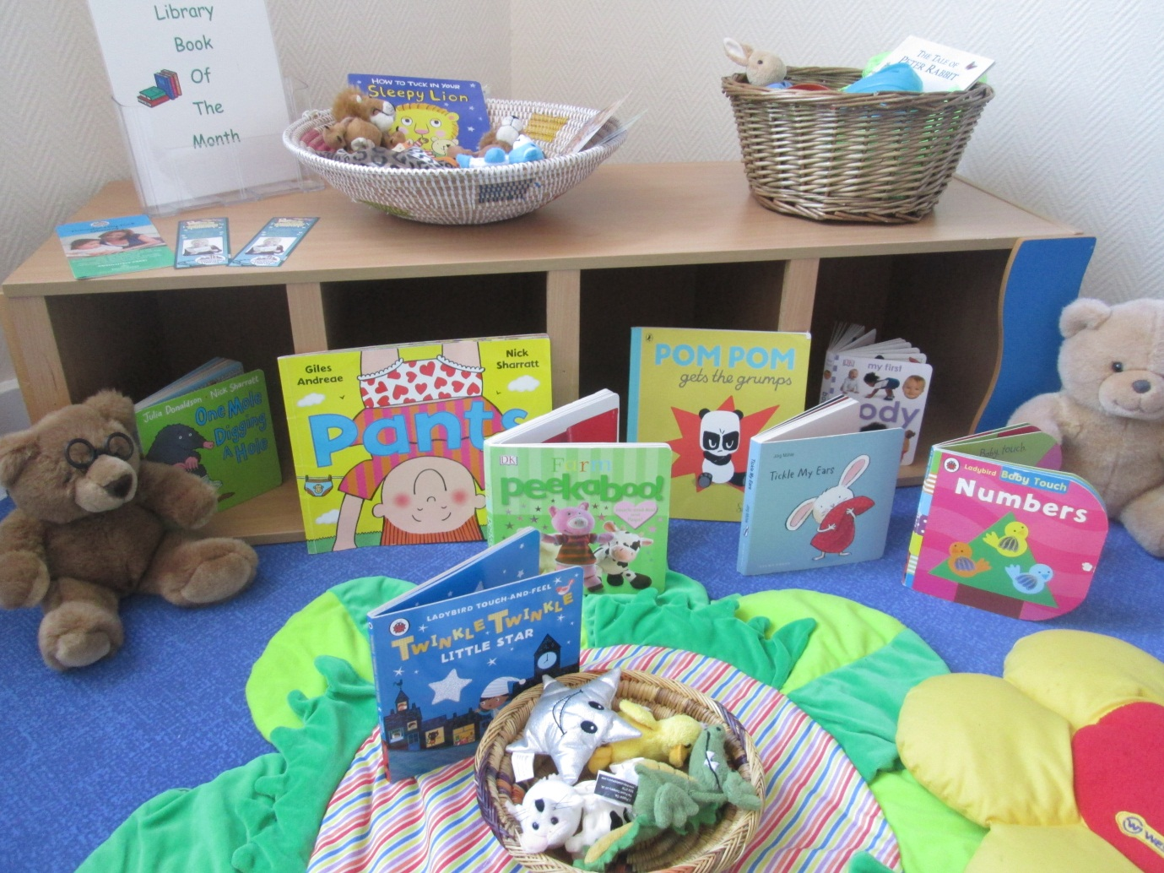

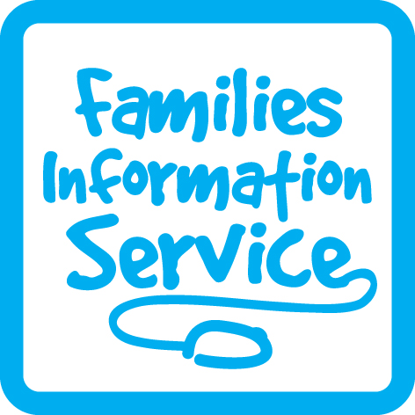

All activities are free of charge unless stated!

|  |  |  |  |  |  |
| --- | --- | --- | --- | --- | --- |
| **FAMILY HUB OPENING TIMES** | | | | | |
| **Central** | | **Balby** | | **Wheatley** | |
| Monday | 9.00-5.00pm | Monday | 8.30am-4.30pm | Monday | 9.00-5.00pm |
| Tuesday | 9.00-5.00pm | Tuesday | 8.30am-4.30pm | Tuesday | 9.00-5.00pm |
| Weds | 9.00-12.00pm | Weds | 8.30am-12.00pm | Weds | 9.00-12.00pm |
| Thurs | 9.00-5.00pm | Thurs | 8.30am-4.30pm | Thurs | 9.00-5.00pm |
| Friday | 9.00-4.00pm | Friday | 8.30am-4.00pm | Friday | 9.00-4.00pm |

Intake Children’s Centre

Ardeen Road

DN2 5EU

Family Hub and Youth Action Group support a number of events and activities delivered by the Hub Team

**OTHER PLACES YOU CAN FIND US!**

Please see inside for more details

**CENTRAL LOCALITY FAMILY HUB TIMETABLE**

**10 September 2018**



**We are on Facebook**



Balby Family Hub

1 Sandycroft Crescent, Balby

Doncaster DN4 0TY

Tel: 736880

Central Family Hub

Welcome Way

Doncaster

DN1 3LE

Tel: 737995

Wheatley Family Hub

Old School Way

Beckett Road

Wheatley, Doncaster

DN2 4AJ

Tel: 737790



**Delivered by Partner Agencies**

|  |  |  |  |
| --- | --- | --- | --- |
| Session name | For | Information | How to attend |
| Adult and Family Learning | Adults | Functional Skills Maths  Tuesdays 1.00-3.00pm  Functional Skills English – Tuesdays 9.30-11.30am or 1.00-3.00pm  TERM TIME *- At Central Family Hub* | Please call AFCL Main office  Tel: 862688 |
| ESOL | Adults | Every Friday 10.00am-12.00noon  TERM TIME  *At Central Family Hub* | Come along or see Central Reception |
| Childminder Drop in | 0-4 years | A group that is run by Ofsted Registered Childminders for the children they care for to play in a stimulating, safe and fun environment. This group also give the opportunity for networking | Come along |
| Yorkshire Children’s Centre | Families | Family Contact Sessions by appointment only  *At Central Family Hub* | See Central Reception |

Other services you may use at the Family Hub

but will need an appointment for:

Midwife

Orthoptist

Weaning

Counselling

Baby Massage

Sleep Clinics

**Family Support**

You can request the help of a Family Support Worker if you have any issues that you feel may be affecting your family life e.g. finances, sleep, debt, coping with aspects of your child’s behavior and parenting.

They will arrange an appointment to discuss the support needed. This can be at home or at the Family Hub. Support could include access to a Parenting Programme to help you understand your child better.

**To enquire about Family Support please call: The Early Help Hub Tel: 01302 734110**



|  |  |  |  |
| --- | --- | --- | --- |
| **Delivered in Partnership with Health** | | | |
| Session name | For | Information | How to attend |
| First Friends | Ante-natal to mobile baby | Come and play together within a safe informative and stimulating environment which is welcoming and supportive to all. Health and development advice from a Community Nursery Nurse. | Come along |
| Growing Friends | 0-5 years | Come and play together within a safe informative and stimulating environment which is welcoming and supportive to all. Health and development advice from a Community Nursery Nurse with a focus on school readiness. | Come along |

|  |  |  |  |
| --- | --- | --- | --- |
| Session name | For | Information | How to attend |
| Raza Academy | School age children | *At Wheatley Family Hub*  Week nights 5.00-6.30pm  Arabic Lessons  Places limited | Please leave your details with Wheatley Reception |
| Counselling | Children,  young people and adults | *Available at all Family Hubs* | See Reception |

**Delivered by Partner Agencies**

**Breastfeeding Peer Supporters**

This is a woman who has breastfed a baby herself, lives in your area and has undergone training in breastfeeding and supporting other women and their families. Breastfeeding Peer Supporters are available to talk with and offer information, tips and suggestions. They also promote breastfeeding in the community.

**If you have breastfed a baby and are interested in supporting breastfeeding mothers, please ask us about training as a Breastfeeding Peer Supporter**.

**Volunteering**

Volunteering is a great work experience that enables you to learn new skills, build on the ones you have and get great references.

We are looking for:

**Volunteer Receptionist/Administrators**

**Volunteer Early Years Development Workers**

F**or more information about Volunteering, please ask at Reception**

**Other ways to get involved at the Family Hub**



|  |  |  |  |
| --- | --- | --- | --- |
| Session name | For | Information | How to attend |
| DMBC Youth Delivery | Children aged  8-19 years | For information on DMBC Youth Delivery,  please contact:  Bentley My Place  Tel: 01302 737993  or Tom Hill  Tel: 01302 735704 | Ring for more information |
| Junior and Senior  Youth Clubs  Thursday 4.00-6.00pm  6.30-8.30pm | Junior:  Children up to year 6  (8-11 year olds)  Senior:  11-19 | Run by ‘Family Hub and Youth Action Group’  **At Central Family Hub** | Come along |
| Young Carers  Youth Session | 6 years upwards | Please contact the email below for more information  [young.carers@doncaster.gov.uk](mailto:young.carers@doncaster.gov.uk)  **At Central Family Hub** |  |

**Youth Service Delivery**

|  |  |  |  |
| --- | --- | --- | --- |
| Session name | For | Information | How to attend |
| Toddle on to 2 | * | Toddle on can be a useful step towards getting your child ready for nursery. Parents and children can share fun activities like dressing up, signing, sand and water. A snack is provided so children can sit and enjoy a healthy snack and drink together.  \***For children 12 months to the term after their second birthday**. | Come along |
| Toddling to Nursery | 1-3 years | This session introduces children to structure and routine and encourages interaction and independence which helps prepare children for nursery. It includes sensory, music and instruments, physical toys and games, book and stories, singing and snack time. | Come along |
| Let’s Tell a Story | 0-5 years | Let’s Tell a Story supports early language, communication and literacy development. Children learn though music, singing and story time with activities that can be easily completed in the family home. It also gives opportunity for you and your child to meet new friends. | Come along |
| Second Steps | 6 months to 2 years | In this session you and your child can explore activities together to support your child’s development. It includes, turn taking, ideas for home, speech & language with a main activity focused on messy play. | Come along |

**Delivered by Family Hub Staff**



|  |  |  |  |
| --- | --- | --- | --- |
| Session name | For | Information | How to attend |
| Sing and Shake | 0-5  years | This group supports children’s communication and language development. It enables parents to engage with their children in a fun and interactive way. | Come along |
| Jumping Tots | 0-5 years | A fun music and movement group which promotes a healthy lifestyle. It includes song time with music and instruments, physical play activities such as slides, balancing beams and trampolines to develop motor skills. | Come along |
| Active Tots | 0-3 years | This is a version of Jumping Tots for younger children. | Come along |
| Stay and Play | 0-5 years | Come and play together in our safe and exciting play rooms. Activities set out will give you and your child chance to explore and take part in new experiences. You can also meet other parents and make new friends. | Come along |
| Messy Play for Movers | 8-15 months | Come and join in the messy fun. Your child will have the opportunity to play and experiment with different materials and experience different textures. | Come along |
| Play and Say | 0-5 years | This session supports communication and language through a range of structured activities. | Come along |

**Delivered by Family Hub Staff**

|  |  |  |  |
| --- | --- | --- | --- |
| Session name | For | Information | How to attend |
| Breast Start | Ante-natal and breast fed babies | A friendly and relaxed environment that gives an opportunity to meet other mums, share experiences and build your confidence to breast feed with support from peer supporters and a trained Nursery Nurse. | Come along  For more inform-ation Tel: 01302 566776 |
| Infant Massage | From 6 weeks | Learn gentle massage techniques with your baby which will support bonding and attachment, improve baby’s skin and sleep, aid digestion and help reduce colic. | By Invitation  For more inform-ation Tel: 01302 566776 |
| Let’s Eat Together (Weaning) | From 16 weeks | An opportunity to talk to a Nursery Nurse about weaning your baby onto solid food. Advice information and support available to enable you to prepare nutritious food from 6 months. | By Invitation  For more inform-ation Tel: 01302 566776 |
| Midwife | Antenatal and  postnatal parents | Appointments for 1:1 ante-natal and post-natal care with your midwife. Also an opportunity to look around the Family Hub, meet the staff and decide what groups to attend. | By Appoint-ment |

**Delivered by Health**



|  |  |  |
| --- | --- | --- |
| **St Jude’s Church Hall (Central Area)** | | |
| Thursday | | Friday |
| Growing Friends  9.30–11.00am | | Jumping Tots  9.30–10.30am |
| **Quaker Meeting House (Central Area)** | | |
| Thursday | | |
| Information for Asylum Seekers and Refugees  1.00-4.00pm | | |
| **Alder Grove Church Hall (Balby Area)** | | |
| Friday | | |
| Jumping Tots  10.00-11.00am | | |
| **Cantley Health Centre** | | |
| Tuesday | | |
| Breast Start  9.30-11.00am  First Friends  1.00-2.30pm | | |
| **Intake Children’s Centre** | | |
| Tuesday | | |
| First Friends  9.30-11.00am | Play and Say  1.30-2.30pm | |
| **Balby Library** | | |
| Wednesday | | |
| Let’s Tell a Story  10.30-11.30am | | |
| **Central Children’s Library** | | |
| Thursday | | |
| Let’s Tell a Story  1.30-2.30pm | | |

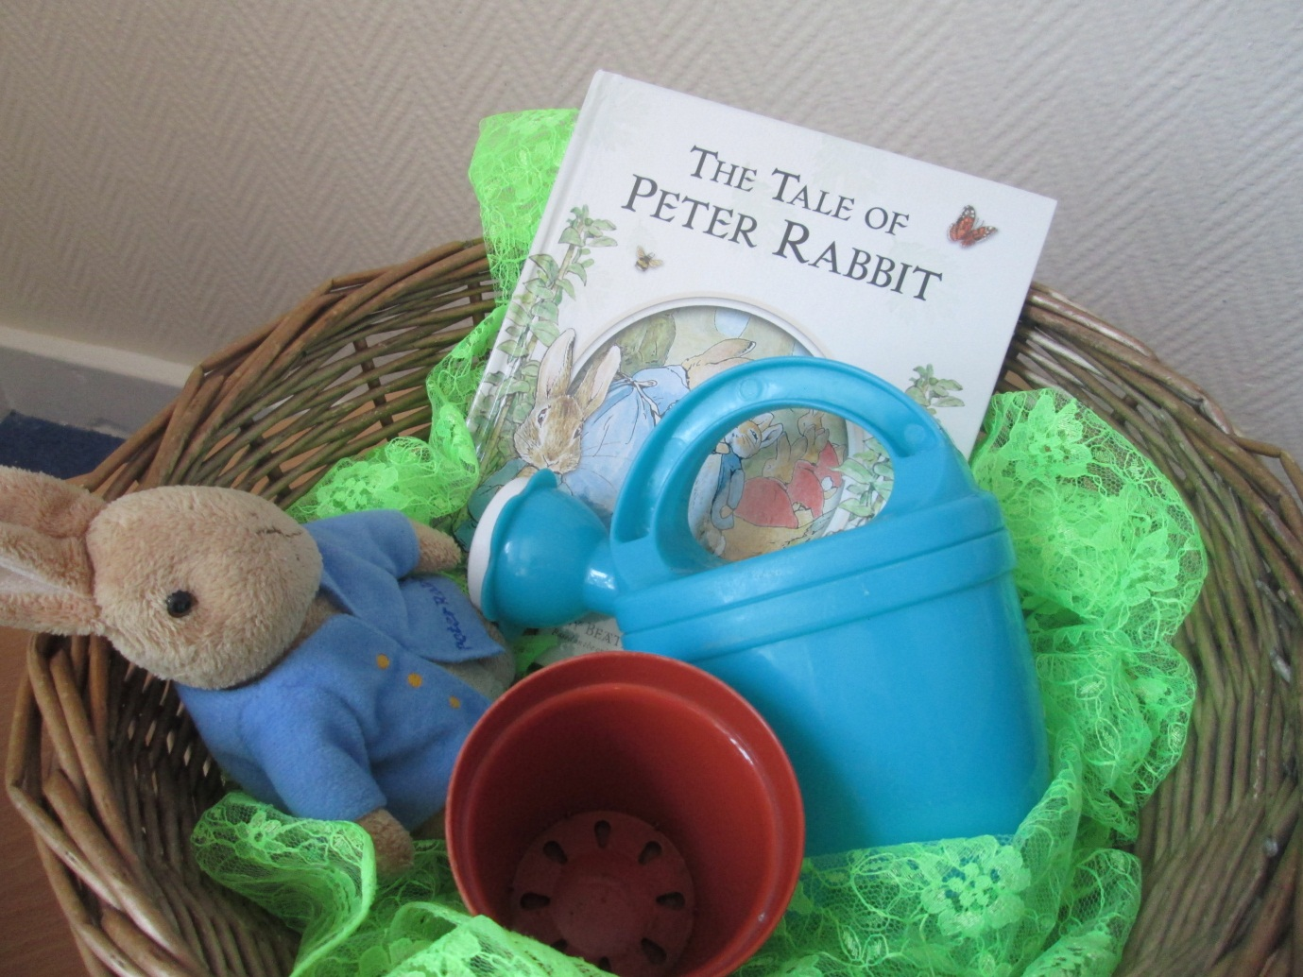

[](https://pixabay.com/en/baby-bite-boy-child-cute-eat-84686/)

**Services delivered by**: Blue – Family Hub

Red – Health Partners, Purple – Other partners, and

Green – Family Hub and Health Partners

**Central Locality – Family Hub delivery**

**September 2018**

|  |  |  |  |  |  |
| --- | --- | --- | --- | --- | --- |
| **Central Family Hub** | | | | | |
| Monday | Tuesday | Wednesday | | Thursday | Friday |
| Midwife  Active Tots  9.15-10.00am  Growing Friends  1.00-2.30pm | Midwife  Stay & Play  10.00-11.30am  Toddling to Nursery  1.30-3.00pm | Midwife  First Friends  9.30-11.00am  Second Steps  9.30-10.30am  Family Hub Closed from 12noon for Staff Training | | Midwife  C:\Users\JadeLe\AppData\Local\Microsoft\Windows\Temporary Internet Files\Content.Word\pcture for timetable.jpg  Infant Massage  (invite only) | Midwife  Childminder Drop in  9.30-11.30am  Stay & Play  1.30-3.00pm |
| **Balby Family Hub** | | | | | |
| Monday | Tuesday | Wednesday | Thursday | | Friday |
| Midwife  Growing Friends  9.30-11.00am  Infant Massage  (invite only) | Midwife  Sing and Shake  9.30-10.30am  First Friends  1.00-2.30pm | Midwife  Childminder Drop in  9.30am-12noon  Family Hub Closed from 12noon for Staff Training | Midwife  Toddle on to Two  9.30-11.00am  Messy Play for Movers  1.30-2.30pm | | Midwife  Children enjoying role play at the South Family Hubs |
| **Wheatley Family Hub** | | | | | |
| Monday | Tuesday | Wednesday | Thursday | | Friday |
| Midwife  First Friends  9.30-11.00am  Second Steps  9.30-10.30am  Sing and Shake  1.00-2.00pm | Midwife  Services delivered **at Intake Childrens Centre**:  Please see page opposite for sessions and times | Midwife  Growing Friends  9.30-11.00am  Family Hub Closed from 12noon for Staff Training | Midwife  Stay and Play  9.30-11.00am  PHIG  1.00-2.30pm  Fortnightly  (Term Time only)  Toddling to Nursery  1.00-2.30pm | | Midwife  Let’s Tell a Story  9.30am-10.30am  Active Tots  11.15am-12.15pm |