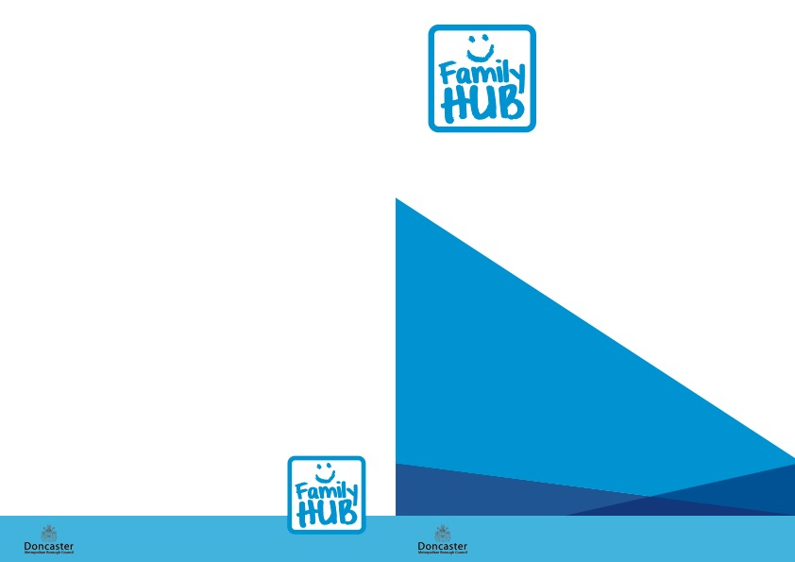

Central Family Hub

Welcome Way

Doncaster

DN1 3LE

Tel: 737995

**We are on Facebook – you can find us under:**

Central Family Hub and

Doncaster Adult, Family and Community Learning

Please check our pages for course updates.



Balby Family Hub

1 Sandycroft Crescent, Balby

Doncaster DN4 0TY

Tel: 570270

Wheatley Family Hub

Old School Way Beckett Road

Wheatley

Doncaster DN2 4AJ

Tel: 737790

Hexthorpe Primary School

Urban Road

Doncaster DN4 0HH

Plover Primary School

Coniston Road

Intake Doncaster DN2 6JL

Doncaster Minster

9 Church Street

Doncaster DN1 1RD

Doncaster Children’s Library

28 Waterdale

Doncaster DN1 3EY

Courses are FREE unless otherwise stated.

FREE childcare may be available – please enquire at Reception.

If there is a course you would be interested in that we don’t currently offer, please let us know so we can explore these options.

**Other Training Venues across Central Locality:**

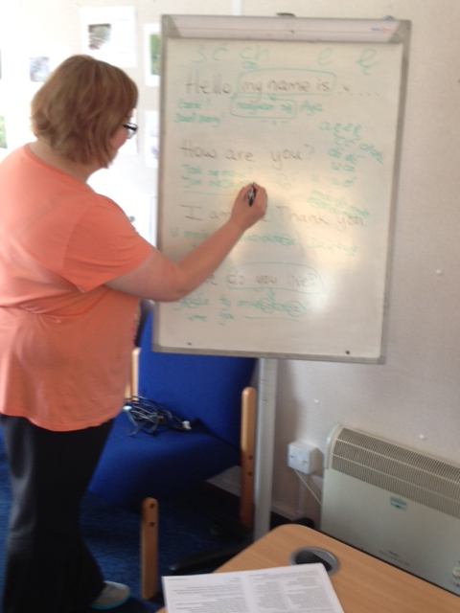

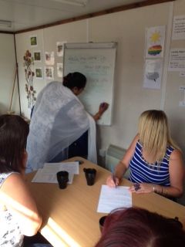

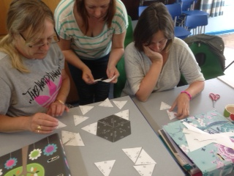

**CENTRAL LOCALITY FAMILY HUBS**

**ADULT LEARNING TIMETABLE**

**September 2018**

**Our Training Venues**



**Parenting**

Current Courses in Central Locality:

**Teen Triple P** (8 week course)

Central Family Hub – starts 20th September 2018

10.00am-12.00pm

**Solihull**

Next course to be confirmed – January 2019

**Incredible Years** (16 week course)

Wheatley Family Hub – starts 3rd October 2018 1.00-3.00pm

**Triple P - Primary aged children** (8 week course)

Wheatley Family Hub – starts 9th October 2018

9.30-11.30am

How to join:

By self-referral through the Early Help Hub

Tel: 01302 734110

Please note if you have a Family Support Worker or Social Worker they can make the referral for you.

The Early Help Hub will discuss your individual needs and decide which the best parenting course is for you.

Please speak to a member of the Family Hub staff for more details and support with accessing any of the courses listed in this booklet

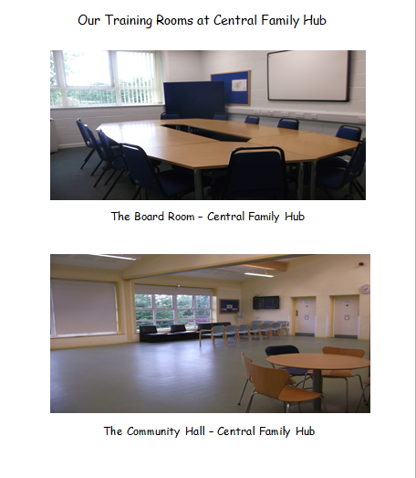



Please speak to a member of the Family Hub staff for more details and support with accessing any of the courses listed in this booklet

**ESOL (Conversation Club Volunteers)**

Every Friday morning (term time)

10:00am – 12:00noon at Central Family Hub

About the Course:

English language lessons for students with English as a foreign language. This session is run by Volunteers from the Quaker Meeting House. They will help you to learn and practice your English speaking, listening, reading and writing.

How to join: Come along to one of the sessions or ask at Central Family Hub Reception for more information.

**Riverside**

About the Courses:

***The Freedom Programme*** – is for men and women who wish to learn more about the reality of domestic violence and abuse, whether they are in, or have left an abusive relationship, or have no plan to leave their partner.

***You and Me, Mum*** – is a self-help programme which will empower support and develop further understanding of your role as mothers in addressing the needs of children and young people who have lived with domestic violence.

How to join: For more information, or to self-refer, please call 0800 4701 505 or email [victoriahouseservices@riverside.org.uk](mailto:victoriahouseservices@riverside.org.uk)

Alternatively, speak to a member of the Family Hub Team to request support with accessing the groups.



To book on please contact the

Health Team on Tel: 01302 566776

**Antenatal Solihull Classes**

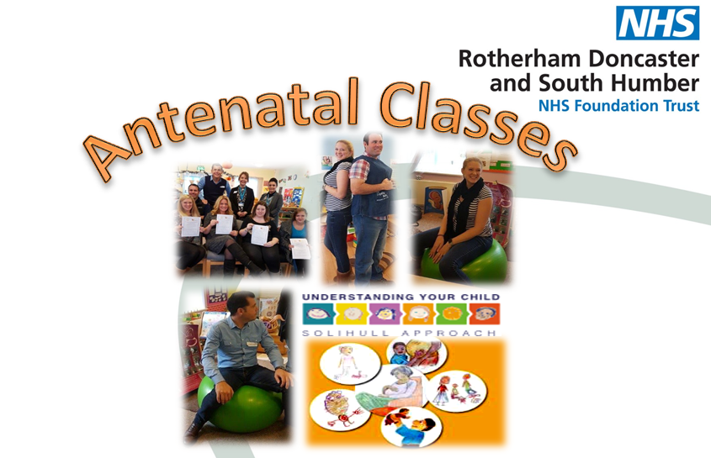

**Understanding pregnancy, labour, birth and your baby**

These Antenatal classes follow a Solihull Approach over a five week period and are facilitated across Doncaster. They are available to every pregnant woman, her partner or supporter, living in the Doncaster Region.

**These five classes include:**

* Helping you and your baby through pregnancy and birth
* Getting to know your baby in the womb
* You, your baby and the stages of labour
* Helping you and your baby through labour and birth
* Feeding your baby.

**Balby Family Hub**

28th August to 25th September 2018 1.00-3.00pm

**Central Family Hub**

23rd October to 20th November 2018 9.30-11.30am

**Wheatley Family Hub**

8th January to 5th February 2019 12.30-2.30pm

Please speak to a member of the Family Hub staff for more details and support with accessing any of the courses listed in this booklet.

.

Please speak to a member of the Family Hub staff for more details and support with accessing any of the courses listed in this booklet

**AFCL - Functional Skills English and Maths**

26 week courses at Central Family Hub every Tuesday

(term time)

About the Courses:

Functional skills support the development of practical skills in English or Maths. They are designed to help learners gain the most out of work, education and everyday life. There is a strong focus on explanation and problem solving. Courses are **FREE** for learners without a Grade C or equivalent GCSE.

***English*** classes cover reading, writing and speaking and listening.

***Maths*** classes cover number, measuring shape and space and handling data.

***************************************************

**AFCL – ESOL**

About the Course:

ESOL qualifications will help you demonstrate your ability to communicate in English to enable you to work or study in English-speaking countries and/or environments. Speaking English in educational and social situations. Essentially these qualifications are proficiency tests to assess your ability to communicate in English, so you do not necessarily learn but demonstrate your skills.

How to join: Learners must be 19+ to enrol on AFCL courses.

For more information, or to arrange an assessment, please call the AFCL office Tel: 01302 862688.



**Personal Counselling**

About the sessions: Doncaster Children’s Services Trust offer FREE 1:1 Therapeutic Counselling for children from 7 years old up to adulthood and for parents / carers living within Doncaster.

Counsellors work alongside DMBC and sessions take place in locality based Family Hubs.

Counselling sessions are confidential and Counsellors work in ways that are respectful and caring, giving those accessing the service opportunities to able to be open and honest about what **they** choose to bring to sessions.

How to access:

You can enquire, or self-refer, by contacting the Early Help Hub on 01302 734110. Alternatively, you can speak to a member of the Family Hub Team.

**AFCL – Conversational English**

About the Course

This class is aimed at supporting learners to improve their spoken English and making steps toward reading and writing.  Activities will include role plays, grammar drills with a particular focus on tenses and word order.  This class is for the more advanced learner.

About the Course – Basic level

This class is to support learners to begin to speak English confidently and accurately.  Activities will include role plays, grammar exercises and the first steps toward reading and writing in English.  This class is for the beginner and will hopefully lead into a qualification.

Please speak to a member of the Family Hub staff for more details and support with on accessing any of the courses listed in this booklet

Please speak to a member of the Family Hub staff for more details and support with accessing any of the courses listed in this booklet



|  |  |  |  |  |  |  |  |
| --- | --- | --- | --- | --- | --- | --- | --- |
| **Central Family Hub** | | | | | | | |
| Monday | Tuesday | | Wednesday | | Thursday | Friday | |
| 12.30 – 2.30pm  AFCL Functional Skills  Maths | 9.30-11.30am  and  1.00-3.00pm  AFCL Functional Skills  English  9.30-11.30am  Antenatal Solihull | | Bradley's Book Outlet - Bestsellers, overstocks and remainders at | | 10.00am-12.00pm  Teen  Triple P | 10.00am-12.00noon  ESOL  11.30am-4.00pm  Counselling  1.00-3.00pm  AFCL Conversational English | |
|  | | | | | | | |
| **Wheatley Family Hub** | | | | | | | |
| Monday | | Tuesday | Wednesday | Thursday | | | Friday |
| 11.00am-12.00noon  Counselling | | 10.30am-5.00pm  Counselling  12.30-2.30pm  Antenatal Solihull  9.30am-11.30am  Teen Triple P | 10.30am – 3.30pm  Counselling  1.00-3.00pm  Incredible Years | 11.00am – 4.00pm  Counselling | | | 9.15am-3.30pm  Counselling |

[](http://www.google.co.uk/url?url=http://cliparting.com/free-ear-clipart-11944/&rct=j&frm=1&q=&esrc=s&sa=U&ved=0ahUKEwjLzfXLo5_WAhXGKcAKHZgoCUQQwW4IKTAF&usg=AFQjCNGjwZZSNGWasYTZ41m4qB_lUkJPRQ)

|  |  |  |  |  |
| --- | --- | --- | --- | --- |
| **Balby Family Hub** | | | | |
| Monday | Tuesday | Wednesday | Thursday | Friday |
| 9am - 3.30pm  Counselling | 12.15 - 4.15pm  Counselling  1.00-3.00pm  Antenatal Solihull | 9am - 4.30pm  Counselling |  | 9am - 3.30pm  Counselling |

|  |  |
| --- | --- |
| **Doncaster Minster** | |
| Tuesday  Thursday | 1.00-3.00pm – AFCL ESOL  1.00-3.00pm – AFCL ESOL |

|  |  |
| --- | --- |
| **Hexthorpe Primary School** | |
| Monday | 9.00-11.00am AFCL Maths |
| Tuesday | 9.00-11.00am AFCL Maths |
| Thursday | 1.00-3.00pm – AFCL Functional Skills English |

|  |  |
| --- | --- |
| **Intake Plover Primary School** | |
| Monday | 9.00-11.00am AFCL Maths |
|  | |
| **Doncaster Children’s Library** | |
| Tuesday  Thursday | 9.30am-12.30pm AFCL ESOL  9.30am-12.30pm AFCL ESOL |
|  | |
| **Park Primary School** | |
| Wednesday | 1.15 – 3.00pm - AFCL – ESOL |

Courses delivered as follows:

**Red**: Term Time **Green**: Throughout the year

**Purple**: Course runs over a set period of weeks

(see course description)