

Cantley Health Centre

10 Middleham Road

DN4 6BZ

St Jude’s Church Hall

146 Shadyside

Hexthorpe DN4 0DG

Central Children’s Library

Waterdale

DN1 3JE

Balby Library

High Road

DN4 0PL

Quaker Meeting House

Oxford Place

DN1 3SL

Alder Grove Church Hall

Alder Grove

DN4 8RF

Intake Children’s Centre

Ardeen Road

DN2 5EU



Family Hub and Youth Action Group Support a number of events and activities delivered by the Hub Team

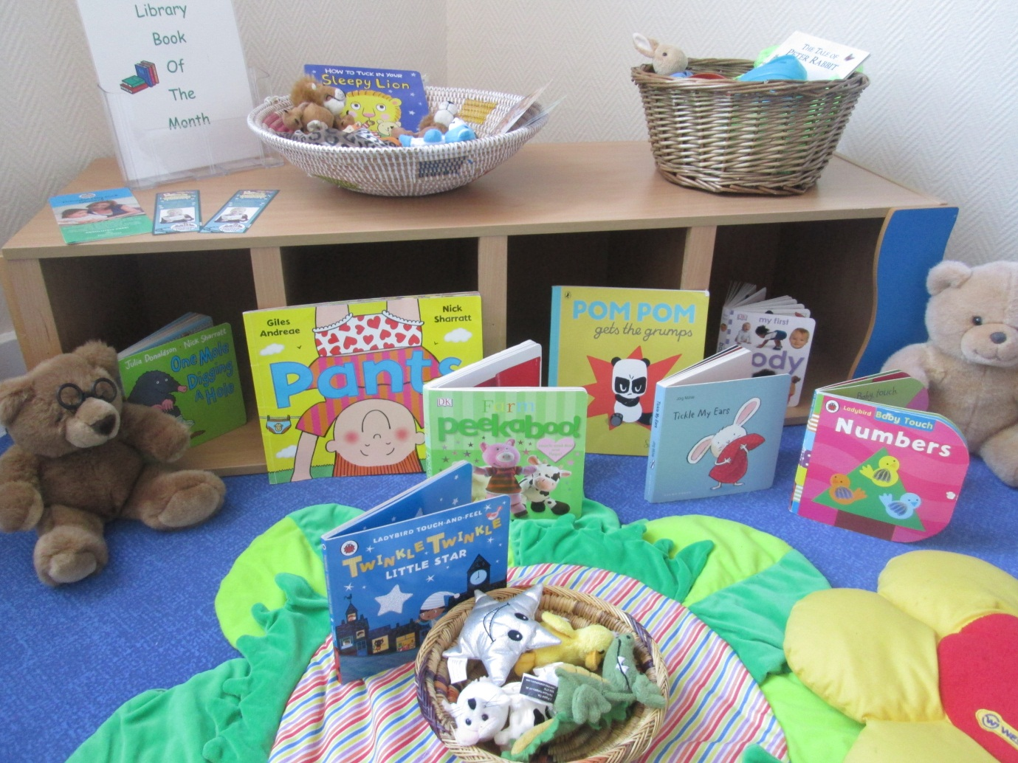

**CENTRAL LOCALITY FAMILY HUB TIMETABLE**

**From 10th September 2018**

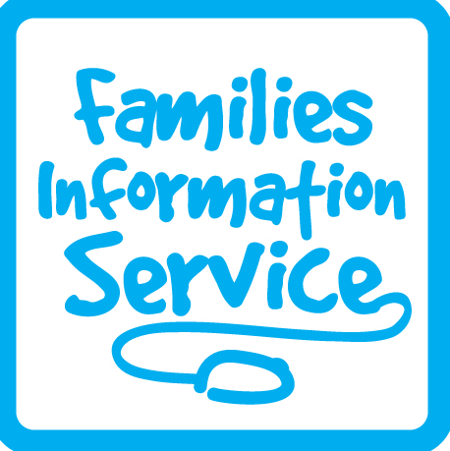

All activities are free of charge unless stated!

|  |  |  |  |  |  |
| --- | --- | --- | --- | --- | --- |
| **FAMILY HUB OPENING TIMES** | | | | | |
| **Central** | | **Balby** | | **Wheatley** | |
| Monday | 9.00-5.00pm | Monday | 8.30am-4.30pm | Monday | 9.00-5.00pm |
| Tuesday | 9.00-5.00pm | Tuesday | 8.30am-4.30pm | Tuesday | 9.00-5.00pm |
| Weds | 9.00-12.00pm | Weds | 8.30am-12.00pm | Weds | 9.00-12.00pm |
| Thurs | 9.00-5.00pm | Thurs | 8.30am-4.30pm | Thurs | 9.00-5.00pm |
| Friday | 9.00-4.00pm | Friday | 8.30am-4.00pm | Friday | 9.00-4.00pm |

**OTHER PLACES YOU CAN FIND US!**

See inside for more details



**We are on Facebook**



Balby Family Hub

1 Sandycroft Crescent

Balby, Doncaster

DN4 0TY

Tel: 736880

Central Family Hub

Welcome Way

Doncaster

DN1 3LE

Tel: 737995

Wheatley Family Hub

Old School Way Beckett Road Wheatley, Doncaster

DN2 4AJ

Tel: 737790



**Central Area – Family Hub Delivery**

**From September 2018**

**Services delivered by: Blue – Family Hub, Red – Health Partners,**

**Purple – Other Partners and Green – Family Hub and Health Partners**

[](https://pixabay.com/en/baby-bite-boy-child-cute-eat-84686/)

|  |  |
| --- | --- |
| **St Jude’s Church Hall (Central Area)** | |
| Thursday | Friday |
| Growing Friends  9.30–11.00am | Jumping Tots  9.30–10.30am |
| **Quaker Meeting House (Central Area)** | |
| Thursday | |
| Information for Asylum Seekers and Refugees  1.00-4.00pm | |
| **Alder Grove Church Hall (Balby Area)** | |
| Friday | |
| Jumping Tots  10.00–11.00am | |
| **Cantley Health Centre** | |
| Tuesday | |
| Breast Start  9.30-11.00am  First Friends  1.00-2.30pm | |
| **Intake Children’s Centre** | |
| Tuesday | |
| First Friends  9.30-11.00am  Play and Say  1.30-2.30pm | |
| **Balby Library** | |
| Wednesday | |
| Let’s Tell a Story  10.30-11.30am | |
| **Central Children’s Library** | |
| Thursday | |
| Let’s Tell a Story  1.30-2.30pm | |

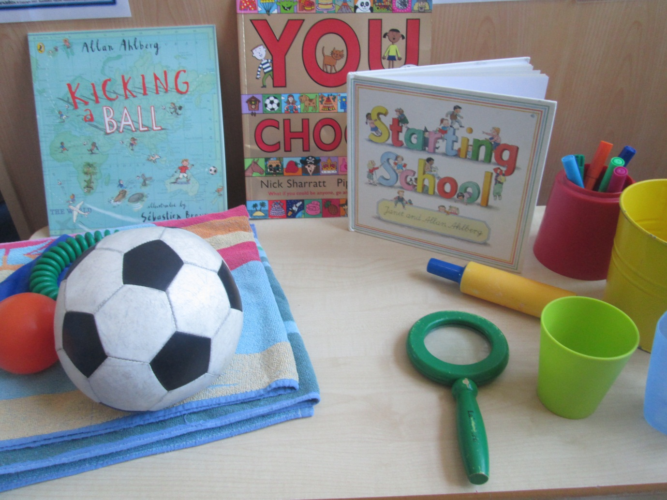

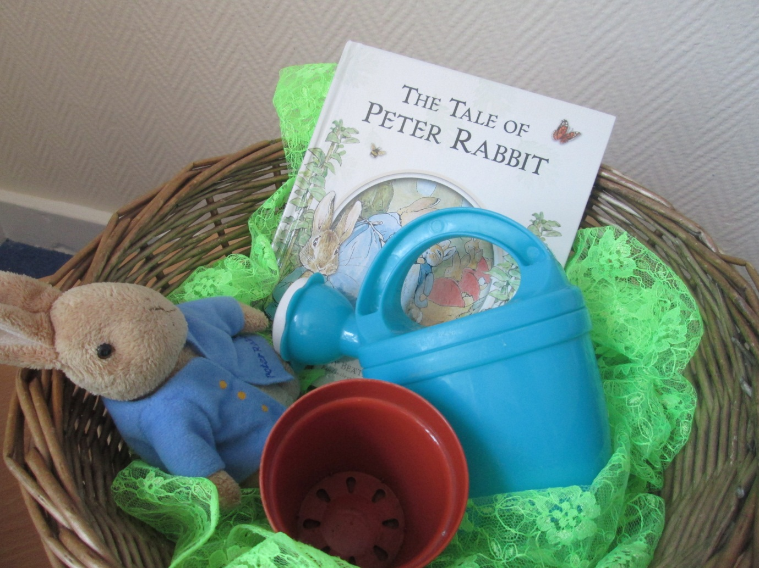



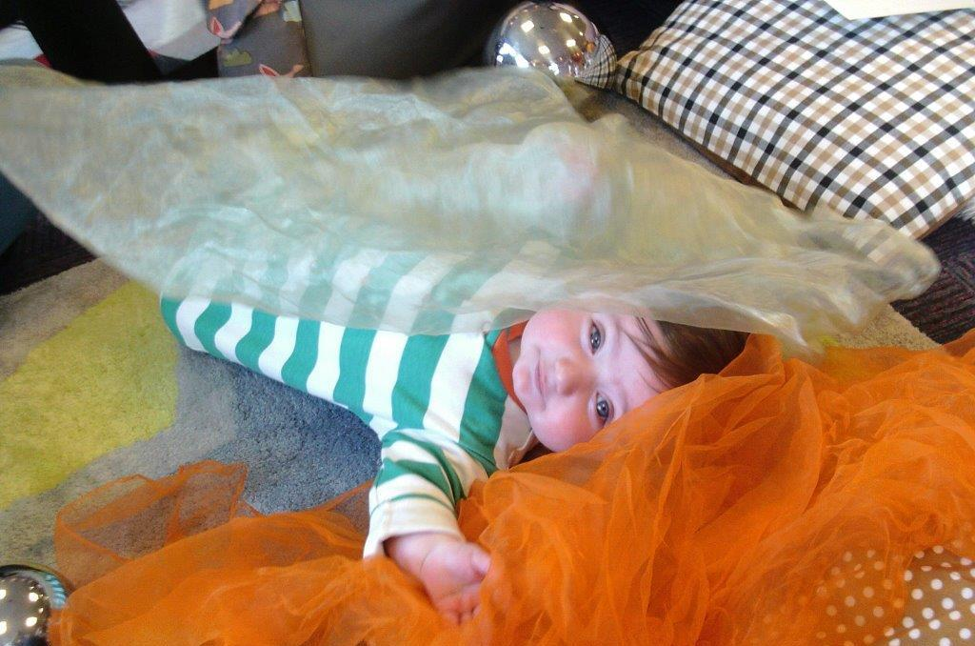

|  |  |  |  |  |  |  |  |  |  |  |
| --- | --- | --- | --- | --- | --- | --- | --- | --- | --- | --- |
| **Central Family Hub** | | | | | | | | | | |
| Monday | | | Tuesday | | Wednesday | | Thursday | | Friday | |
| Midwife  Active Tots  9.15–10.00am  Growing Friends  1.00-2.30pm | | | Midwife  Stay & Play  10.00-11.30am  Toddling to Nursery  1.30- 3.00pm | | Midwife  First Friends  9.30-11.00am  Second Steps  9.30-10.30am  Family Hub closed from 12.00noon for Staff Training | | Midwife  Infant Massage  (invite only) | | Midwife  Childminder Drop In  9.30–11.30am  Stay & Play  1.30-3.00pm | |
|  |  | | |  |  | |  | |  | |
| **Balby Family Hub** | | | | | | | | | | |
| Monday | | | Tuesday | | Wednesday | | Thursday | | Friday | |
| Midwife  Growing Friends  9.30-11.00am  Infant Massage  (invite only) | | | Midwife  Sing & Shake  9.30–10.30am  First Friends  1.00–2.30pm | | Midwife  Childminder Drop In  9.30am–12.00pm  Family Hub closed from 12.00noon for Staff Training | | Midwife  Toddle On to Two  9.30–11.00am  Messy Play for Movers  1.30-2.30pm | | Midwife | |
|  | |  |  | | |  | |  | |  |
| **Wheatley Family Hub** | | | | | | | | | | |
| Monday | | | Tuesday | | Wednesday | | Thursday | | Friday | |
| Midwife  First Friends  9.30-11.00am  Second Steps  9.30-10.30am  Sing & Shake  1.00-2.00pm | | | Midwife  Services delivered at **Intake** – please see page opposite for details | | Midwife  Growing Friends  9.30-11.00am  Family Hub closed from 12.00noon for Staff Training | | Midwife  Stay and Play  9.30-11.00am  PHIG  1.00-2.30pm  Fortnightly  (Term Time only)  Toddling to Nursery  1.00-2.30pm | | Midwife  Let’s Tell a Story  9.30-10.30am  Active Tots  11.15am-12.15pm | |